**Sanjith R**

**241059044**

**Topic Name:**

The main aim of this lab session is to provide hands-on experience on

**Explore file structure**

1. **\*\*/** - Root directory**: The top-level directory of the file system.
2. **\*\*/bin** - Binary files**: Contains essential command binaries for all users.
3. **\*\*/boot** - Boot files**: Contains boot loader files and the Linux kernel.
4. **\*\*/dev** - Device files**: Contains device files for all hardware devices.
5. **\*\*/etc** - Configuration files:** Contains system-wide configuration files and scripts. **\***
6. **\*\*/lib** - Shared libraries**: Essential shared libraries and kernel modules.
7. **\*\*/proc** - Process information**: Virtual file system for process and system info.
8. **\*\*/sbin** - System binaries**: Essential binaries for system administration.
9. **\*\*/tmp** - Temporary files**: Stores temporary files, cleared upon reboot.
10. **\*\*/var** - Variable files**: Logs, spools, and temporary files for various processes.

**File Types**

| **File Type** | **Represented by (Hint: ls)** | **Role** | **How to create** | **How to check** | **Location** |
| --- | --- | --- | --- | --- | --- |
| Regular file | - | Store data, text, or binary information. | touch file | ls -l | /home |
| Text file | - | Store plain text. | touch file.txt | ls -l | /home |
| Compressed file |  | Store compressed data. | gzip file | file file.gz | /var |
| Image |  | Store image data. | convert | file image | /images |
| Directory | d | Organize files. | mkdir dir | ls -ld | / |
| Block file | b | Represent block devices. | mknod | ls -l | /dev |
| Character file | c | Represent character devices. | mknod | ls -l | /dev |
| Socket file | s | Facilitate communication between processes. | socket | ls -l | /run |
| Pipe file | p | Facilitate inter-process communication. | mkfifo | ls -l | /tmp |

1. Globbing
   * 1. List all files starting with file

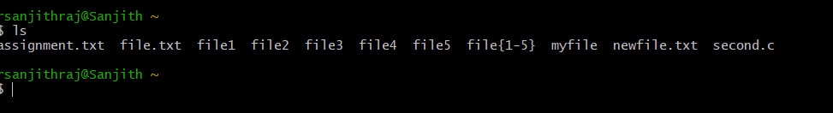

* + 1. List all files starting with File

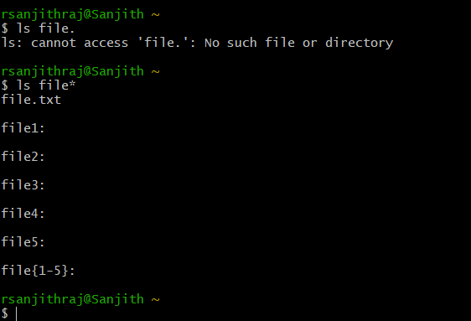

* + 1. List all files starting with file and ending in a number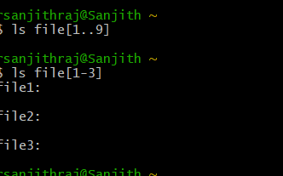
    2. List all files starting with file and ending with a letter

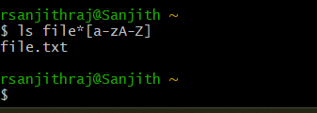

* + 1. List all files starting with File and having a digit as fifth character.

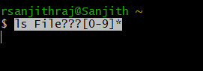

* + 1. List all files starting with File and having a digit as fifth character and nothing else.

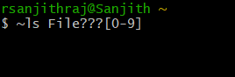

* + 1. List (with ls) all files starting with a letter and ending in a number.

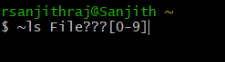

* + 1. List (with ls) all files that have exactly five characters.

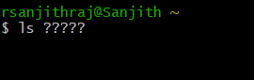

* + 1. List (with ls) all files that start with f or F and end with 3 or A.

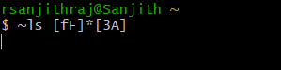

* + 1. List (with ls) all files that start with f have i or R as second character and end in a number.



* + 1. List all files that do not start with the letter F.

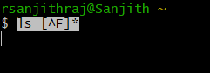

* + 1. Remove all the *.html

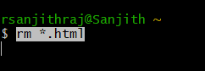

* + 1. Rename *.txt to *.json

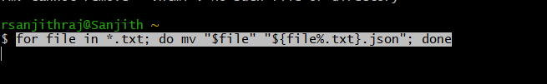

1. Absolute path and relative path

Rm



Mv



Cp

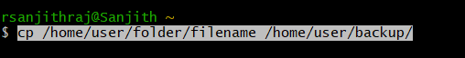

Ls

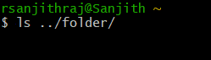

1. Wildcards

|  |  |  |  |
| --- | --- | --- | --- |
| Notation | Use | Example | Screenshot |
| * | Matches any number of characters | ls file* lists all files starting with "file". |  |
| ? | Matches a single character | ls file?.txt lists files like file1.txt, fileA.txt |  |
| [ ] | Matches any single character within the brackets | ls file[123].txt lists file1.txt, file2.txt, file3.txt |  |
| [! ] | Matches any character that is not a member of the set characters | ls file[!a-c].txt lists files not starting with a, b, or c. |  |
| { } | Matches any one of the comma-separated patterns within the braces | ls file{1,2}.txt lists file1.txt and file2.txt. |  |

More on Character class

|  |  |  |  |
| --- | --- | --- | --- |
| Notation | Use | Example | Screenshot |
| [:alnum:] | |  | | --- | | Matches any alphanumeric character (letters and digits) |  |  | | --- | |  | | ls *[[:alnum:]].txt |  |
| [:alpha:] | |  | | --- | | Matches any alphabetic character (letters only) | | ls *[[:alpha:]].txt |  |
| [:digit:] | |  | | --- | | Matches any digit (0-9) | | |  | | --- | | ls *[[:digit:]].txt | |  |
| [:lower:] | |  | | --- | | Matches any lowercase letter |  |  | | --- | |  | | ls *[[:lower:]].txt |  |
| [:upper:] | |  | | --- | | Matches any uppercase letter |  |  | | --- | |  | | ls *[[:upper:]].txt |  |

4. change permission

1. Change the permission set of /work/readme.txt so that only the user (owner) can read,write, and execute it. Use absolute mode.

chmod 700 /work/readme.txt

1. Change the permission set of /work/readme.txt so that any user can read it, the group can read/write to it and the user (owner) can read/write/execute it. Use absolute mode.

chmod 764 /work/readme.txt

1. Change the permission set of /bin/bash so that only the user (owner) can read/write/ execute, group, and any user can execute it. However, whenever anyone executes it, it should run with the privileges of the owner user. Use absolute mode.

chmod 4755 /bin/bash

1. Change the permission set of /work/readme.txt so that only the user (owner) can read, write, and execute it. Use relative mode.

chmod u+rwx,g-rwx,o-rwx /work/readme.txt

1. Change the permission set of /work/readme.txt so that any user can read it, the group can read/write to it and the user (owner) can read/write/execute it. Use relative mode.

chmod 700 /work/readme.txt

chattr +i /work/readme.txt

1. Change the permission set of /work/readme.txt so that only the user (owner) can read/write/ execute, group, and any user can execute it. However, whenever anyone executes it, it should run with the privileges of the group. Use absolute mode.

chmod 2755 /work/readme.txt

1. Change the permission set of /work/readme.txt so that only the owner can rename or delete this file while maintaining the existing permissions. Use absolute mode.

ls -l

1. What are the default permissions for the new file?

chmod 444 chmod.exercises

1. What was the command to view the file permissions?

chmod 640 chmod.exercises

1. Change chmod.exercises permissions to -r--r--r—

chmod 751 chmod.exercises

1. Change the file permissions to Read only for the owner, group and all other users.

chmod 444 filename

1. What was the command for changing the file permissions to -r--r--r--?

chmod 444 filename

1. Change chmod.exercises permissions to -rw-r-----

chmod 640 chmod.exercises

1. Change the file permissions to match the following:
   1. owner: Read and Write
   2. group: Read
   3. other: no permissions (None)

chmod 640 filename

1. What was the command for changing the file permissions to -rw-r-----?

chmod 640 filename

1. Change chmod.exercises permissions to -rwxr-x—x

chmod 751 chmod.exercises

1. Change the file permissions to match the following:
   1. owner: Read, Write and Execute
   2. group: Read and Execute
   3. other: Execute

chmod 751 filename

1. What was the command for changing the file permissions to -rwxr-x--x?

chmod 751 filename